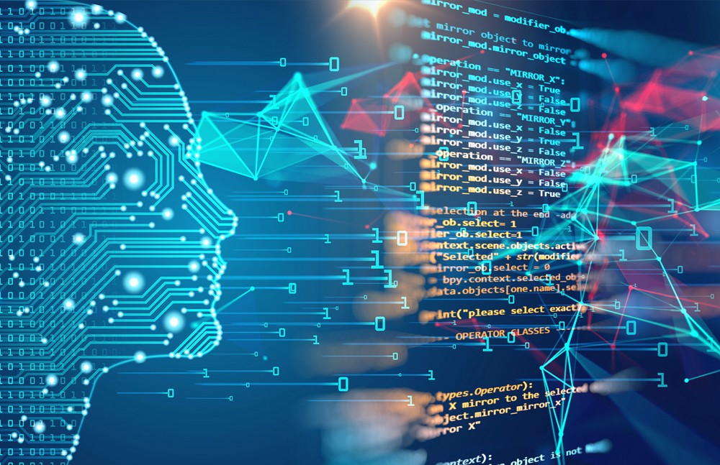

**MACHINE LEARNING**

**Machine learning** is an application of artificial **intelligence** (AI) that provides systems the ability to automatically learn and improve from experience without being explicitly programmed. The purpose of **machine learning** is to discover patterns in your data and then make predictions based on often complex patterns to answer business questions, detect and analyse trends and help solve problems.

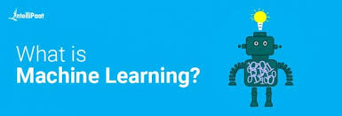

**Machine learning** focuses on the development of computer programs that can access data and use it learn for themselves. For **example**, medical diagnosis, image processing, prediction, classification, **learning** association, regression etc. The intelligent systems built on **machine learning** algorithms have the capability to learn from past experience or historical data. However, **machine learning** remains a relatively '**hard**' problem. There is no doubt the science of advancing **machine learning** algorithms through research is **difficult**. It requires creativity, experimentation and tenacity. **Machine Learning algorithms can be classified into:**

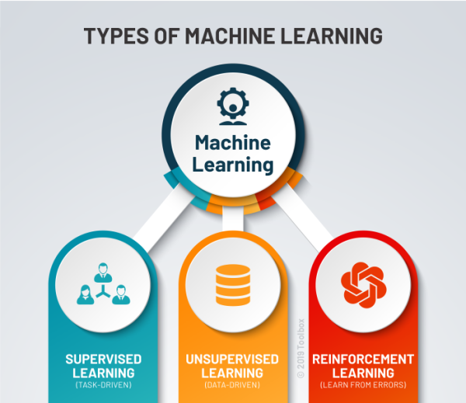

* Supervised Algorithms - Linear Regression, Logistic Regression, KNN classification, Support Vector Machine (SVM), Decision Trees, Random Forest, Naive Bayes' theorem.
* Unsupervised Algorithms - K Means Clustering. Usually, when you step up in **machine learning**, it will **take** approximately 6 months in total to complete your curriculum. If you spend at least 5-6 hours of study. If you follow this strategy then 6 months will be sufficient for you. But that too if you have good mathematical and analytical skills.

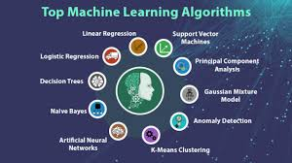

The basic **mathematical** skills **required** are Linear Algebra, Matrix Algebra, Probability and some basic Calculus. Marvin Minsky and Dean Edmonds build the first neural network **machine**, able to learn, the SNARC. Arthur Samuel joins IBM's Poughkeepsie Laboratory and begins working on some of the very first **machine learning** programs, first creating programs that play checkers. **Machine learning** is an application of artificial intelligence (AI) that provides systems the ability to automatically learn and improve from experience without being explicitly programmed. **Machine learning** focuses on the development of computer programs that can access data and use it to learn for themselves. **Machine Learning** can be a rewarding **career** for students who are **good** in mathematics and statistics and have sharp programming skills. The field of **Machine Learning** offers a promising **career** path with lucrative salaries. **Machine Learning** theory is a field that intersects statistical, probabilistic, computer science and algorithmic aspects arising from **learning** iteratively from data and finding hidden insights which can be used to build intelligent applications. **Machine learning** is **popular** because computation is abundant and cheap. Abundant and cheap computation has driven the abundance of data we are collecting and the increase in capability of **machine learning** methods. ... There is an abundance of data to learn from. There is an abundance of computation to run methods

